Word Template for a MAMM-2014 Paper
E.-C. Lovasz¹ and B. Corves²
¹University Politehnica Timisoara, Romania, e-mail: erwin.lovasz@mec.upt.ro
²RWTH Aachen University, Germany, e-mail: corves@igm.rwth-aachen.de
Abstract. MAMM-2014 conference aims to provide a special opportunity for scientists to exchange their know-how and build up collaboration in the mechanism science field and its applications. Each submission will be thoroughly reviewed. The Scientific Committee will choose the papers to be published in a book edited by Springer. The format of your paper is defined in this MS Word sample and contains the prescribed styles necessary to be published by Springer. Your manuscript must be sent in Word (2003- 2010) format with figures attached in eps-format to mamm-2014@mec.upt.ro. Please attach also a complete version in pdf-format for double-checking.
Key words: Please indicate four to five keywords, which will be used for composing the Subject Index (written in 8 pt, justified).
1 Introduction
The manuscript should comprise of up to 8 pages (even number of pages mandatory). A manuscript of more than 8 pages will not be accepted. The font used in this Template is Times. Please, do not use other similar fonts.
Use author style and Affiliation style for automatic formatting of authors’ names (10 pt, left alignment) and their affiliation (10 pt, left alignment). Abstract is written in 8 pt, justified. Please use abstract style.
The paper should contain an abstract, an introduction, a main text, conclusions, and references.
The title of the paper should be written in 16 pt bold, Alignment left ( title style). Section titles require 14pt bold, alignment left (subtitle style). Subsection titles should be written in 14pt bold italic, alignment left (subsubtitle style). The following standard numbering is prescribed: 2, 2.1, 2.2 etc. Instead of simply listing headings of different levels, we recommend to let every heading followed by at least a short passage of text.
Several examples of typical equation, figure, table, citations and references follow. Please do not change the proposed formatting by introducing other styles or by changing this template.
1.1 Paragraphs and indents
Please note that the first line of text that follows a heading is not indented (first line style), whereas the first lines of all subsequent paragraphs are (normal style). The text is 10 pt, justified. Spacing of the text is 12pt.
2 Equations
Equation style bases on Normal style. However, single space is recommendable. Equations should be centered and numbered (equation style). Figure 1 presents the styles and sizes for equations. They should be referenced in the text in round brackets - for instance, (1). An example of equation is as follows:
$G=\left(\begin{matrix}1 & 0 & 0 & 0 \\ a_{i} & 1 & 0 & 0 \\ 0 & 0 & \text{cos}(α_{i}) & −\text{sin}(α_{i}) \\ d_{i} & 0 & \text{sin}(α_{i}) & \text{cos}(α_{i})\end{matrix}\right) \text{.}$ (1)
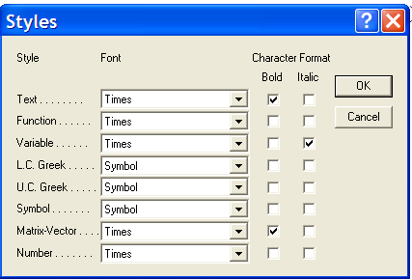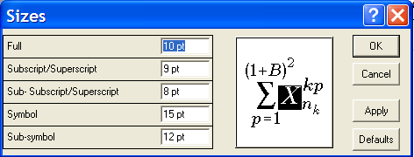
Fig. 1 Equation formatting
3 Figures
Figures should be centered and referenced in text (for example, Figure 2). The font size in figures should be as Normal text (10 pt). Captions are placed under the figure, written in 8.5pt, using figlegend style. Follow the example.

Fig. 1. The geometry, kinematics and forces equilibrium on a current position of a cam mechanism with roll translating follower
4 Tables
Tables should be centered and referenced in the text (for example, Table 1). The font size in tables should be table styled (8.5pt). Captions are centered and placed above the table (Table legend style).
Table 1. Please write your table caption here
Description 1 | Description 2 | Description 3 | Description 4
Row 1, Col 1 | Row 1, Col 2 | Row 1, Col 3 | Row 1, Col 4
Row 2, Col 1 | Row 2, Col 2 | Row 2, Col 3 | Row 2, Col 4
Row 3, Col 1 | Row 3, Col 2 | Row 3, Col 3 | Row 3, Col 4
5 Referencing
The reference list should be in an alphabetical order. A citation in the paper should have the form [1, 2, 3, 4] for a contribution in conference proceedings, monograph, journal article and so on.Use references style (8.5 pt).
6 Conclusions
Send your manuscript to the e-mail address mamm-2014@mec.upt.ro. Please respect the deadlines given on the MAMM webpage: http://mamm-2014.mec.upt.ro
Acknowledgments The research work reported here was possible within the Grant No. 88 CEEX of Research Council. Use acknowledgement style.
References
1. Ceccarelli, M.: The Challenges for Machine and Mechanism Design at the Beginning of the Third Millennium as Viewed from the Past. In: Proceedings of Brazilian Congress on Mechanical Engineering COBEM2001, Uberlandia, Invited Lecture, pp. 132-151 (2001).
2. Angeles J., Lopez-Cajun C.S.: Optimization of Cam Mechanisms. Kluwer Academic Publi-shers, Dordrecht, 1991.
3. Carra S., Garziera R., Pellegrini M.: Synthesis of cams with negative radius follower and evaluation of the pressure angle. Mech. Mach. Theory 39 (2004) 1017-1032.
4. Chan Y.W., Kok S.S.: Optimum cam design. Int. J. Comput. Appl. Technol. 9 (1) (1996) 34-47.
5. Husty, M. L. and Gosselin C.: On the singularity surface of planar 3-RPR parallel mecha-nisms. Mech. Based Design of Structures and Machines, 36, 411–425 (2008).
6. Porter, R.: Mechanism design for online real-time scheduling. In: Proc. of the ACM Conference on Electronic Commerce (EC’04) (2004) Available via CiteSeer. http://citeseer.ist.psu.edu/article/porter04mechanism.html

